Chapter 12, Solution 34.

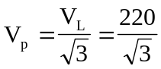

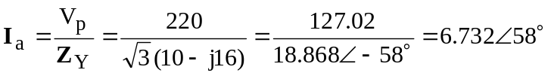

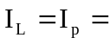 6.732A

S = [1.3592–j2.175] kVA

